Rapid Development of Smart Parking System with Cloud-based Platforms

Zeldi Suryady, Gopinath Rao Sinniah, Shariq Haseeb, M.Tahir Siddique, M. Faheem Mohd. Ezani
Wireless Communication Cluster,
MIMOS Berhad,
Kuala Lumpur, 57000, Malaysia.
Email: {zeldi.suryady,gopinath.rao,shariq.haseeb,mohammad.tahir,faheem.ezani}@mimos.my

Abstract—Smart-parking system is one of necessary component to realize the concept of smart city, especially, in the era of Internet of Things (IOT). However, the traditional way of smart-parking development would have been complex, time consuming and prohibitive. On the other hands, in attempt to accelerate the adoption of Internet of Things, Internet Engineering Task Force (IETF) has been aggressively promoted the use of web services through implementation of Platform as a Service (PaaS) as it allows simple, quick and less complex application development. Therefore, in this paper we discuss the adoption of this approach to gain rapid development of smart-parking system. Furthermore, the integration of parking sensor with IOT middleware and front-end dashboard is also highlighted in this paper.
Keywords-component; Smart-parking, Platform as a Service, Internet of Things (IOT), Middleware, Smart City

Introduction
With the advancement of the Internet of Things (IOT) [1],[2], the Smart-City concept [3],[4],[10] is gaining its momentum as it has great potential for both research and commercial applications. The smart-city concept typically consists of a collection of sub-applications. One of essential aspect in realizing smart-city is implementing a smart-parking solution. We believe that smart-parking is important starting point for Internet of Things, it is one of the low-hanging fruits as far as testing sensor technology goes, because it gives drivers a quick solution to the nagging problem of getting parking occupancy in real time as well as helps city officials reduce congestion and air pollution. Using wireless sensor technology, we can collect data to understand the current state of parking in cities, universities, airports and garages. We can then use this data to offer drivers ways to quickly locate, reserve and pay for parking via free consumer apps for mobile devices.
The proliferation of wireless sensor networks (WSN) has increased attention of many stakeholders in using WSN for the realization of smart-parking system [5]-[8]. Some of the reasons are: (1) WSN have a great potential towards providing an easy and cost effective solution. (2) Ease of deployment in existing parking lots without excavation and expensive cable installations. (3) Flexibility to couple with sophisticated but cheap sensors that can accurately detect vehicles makes WSN a natural candidate to solve the emerging car parking problems.
Smart parking solution using WSN is typically developed by deploying collection of sensor nodes in parking area, these sensor nodes are equipped with functional units such as different kinds of sensing (e.g. magnetic sensor), computation and communication units, hence the nodes able to cooperatively collect, process and transmit parking information to the parking management system in the back-end (e.g Database system, dashboarding system).
To make smart parking reality, it is required to bring all aspect of technology in one integrated system. At least, besides deploying WSN, one should also develop middleware system as well as front-end dashboard. Numerous relevant studies [5],[6],7] have been reported having great challenge in designing end-to-end smart parking since they have to also consider the development of middleware as well as front-end application themselves. As such, the development process is complex, time consuming and prohibitive.
Therefore, we aim to present our experience in developing smart-parking system using available cloud-based Platform as a Service (PaaS). In the context of IOT, The Platform as a Service provides the tools and services needed to create compelling smart parking solution. In our development process, the use of Platform as a Service development environment has resulted in the creation of smart-parking system being significantly faster that would otherwise be the case. In the context of smart-parking system, we leverage two types of Platform as a Service (PaaS); (1) IOT Middleware platform as back-end data platform, (2) Front-end dashboard platform as platform for visualization and reporting.
To simplify the discussion, in this paper, we mainly focus on car park occupancy detection. We also discuss the use of RESTful-API as key enabler in aggregating and linking data together hence heterogeneity and interoperability can be achieved.
This paper is organized as follows: Section II describes the cloud based system architecture of smart-parking system and its functional components. Section III presents the deployment setup of the system. Section IV discusses implementation details. Section V and VI present the conclusion and references of the paper.

System Architecture
In this section, we describe the architecture of smart-parking system. As discussed in section I, the architecture relies on available cloud-based Platform as a Service (PaaS). The architecture consists of Wireless Sensor Network (WSN) layer, IOT middleware layer and Front-end layer as final user interface that provide data reporting to the user. The IOT middleware and Front-end layer are two platforms (PaaS) used is our system to ease the development process.
Figure 1 illustrates the network architecture of the smart-parking system using cloud based PaaS. The system is designed based on a layered and distributed architecture. The overall architecture is divided into three layers representing different classes of functionality. The description of each layer is discussed in the following subsection.

Wireless Sensor Network Layer
Typically a wireless sensor network (WSN) is a wireless network consisting of spatially distributed autonomous sensor nodes to monitor physical or environmental conditions. It also incorporates a gateway that provides wireless connectivity beyond the wireless sensor network itself.
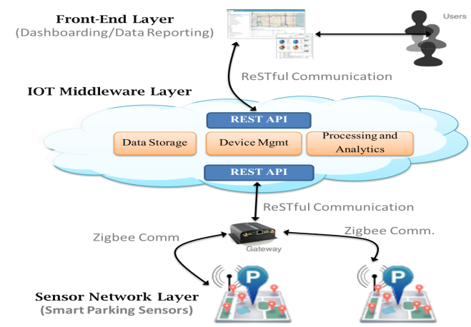

- Network Architecture of Smart Parking System

Sensor Nodes
Sensor nodes are the core component in smart-parking system. It is used to detect free parking spaces quickly and efficiently. When a car is parked/un-parked, the sensor detects the occupancy and sends information to the WSN gateway which will then trigger actions (e.g. translating and forwarding data to middleware). Sensors transmit data to WSN gateway in multi-hop manner using Zigbee protocol. The sensor nodes are exclusively rely on batteries, therefore, power consumption on sensor nodes is kept minimal using energy efficient techniques [11]. Hence, this guarantees a device lifetime of over 2 years.

Gateway
The gateway acts as a bridge between sensor network and IOT middleware. It collects the parking status report from sensor network and delivers them to IOT middleware using REST API.
As depicted in figure 2, the gateway is designed in order to achieve data sharing of sensor network by using advantages of cloud technologies (PaaS). Therefore, the gateway is designed and equipped with two main communication components, Zigbee module to communicate to parking sensor and RESTful module to communicate with IOT middleware. In addition, sensor management and translation module is needed to manage parking sensors and translate Zigbee communication format into REST format, so that the message sent by sensors are understood by IOT Middleware.
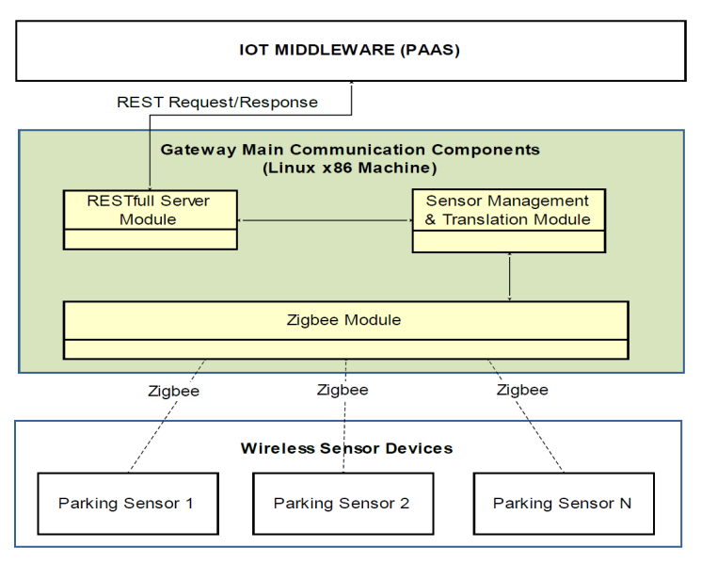
- Main Components of Smart Parking Gateway

IOT Middleware

Basic Principle of IOT Middleware
In service oriented terminology, IOT middleware is also known as IOT Platform. Hence, the terms will be used interchangeably throughout this paper. The IOT middleware aims to transform heterogeneous communication protocol used by any type of devices to common Web Service protocol. In general, the main advantages of using IOT platform is basically the ability to develop, deploy, run, and manage IOT object and applications online via the Cloud [14]. Hence, this approach is becoming industry’s focus in Internet of Things area.
Over the past few years, there are several states of the arts of cloud-based IOT middleware systems available in the market, such as Carriots [12], Xive.ly [13] and some other middleware discussed in [14]. For smart-parking system, we leverage the Carriots IOT platform for our smart parking implementation.
In general an IOT middleware should at least provision with several modules[14], such as Data Storage Module to manage the data, Device Management Module to manage IOT devices/sensors, and Processing Module to execute business logic. On top of those modules, REST API is required as communication module to communicate with other devices or platforms. The REST API is an interface in RESTful web services concept so that it enables data retrieval from external entity.
In the context of our smart-parking system, as shown in Fig 3, every physical parking sensor on Sensor Network Layer is registered and abstracted at Carriots IOT platform to provide device management functionality. Hence this device is called Virtual Device. Each of these devices may have Listeners or Rules. A listener waits for an event to occur in the context of a device and then evaluate its content. For example a listener is “listening” an event called data_received for any incoming data received from car parking sensor.
The raw data of the parking sensors is streamed to Carriots IOT Platform in JSON format, and stored in NoSQL storage. Through provided REST API, the data can be queried or pushed to external entity. The platform also featured with Groovy Scripting Environment so that we can program specific business logic and analytic on the platform. Hence the Groovy Scripting Environment also enables us to create rules engine for rule based processing of incoming data feeds from sensor parking.
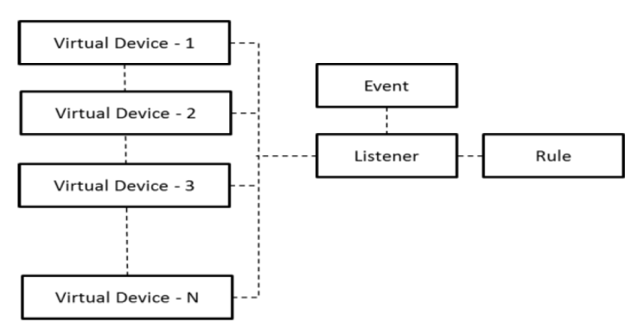
- Virtual Devices and their relation with business logic in IOT Middleware

RESTful Web Services
In Internet of Things, RESTful web services concept is widely used in various IOT Platforms/middleware. It applies Representational State Tranfer (REST) paradigm to the web service. An important concept of REST is the existence of resources (sources of specific information), each of them referenced with a global URI identifier (e.g. http://example.com/resources/). The Restful Web Service component handles all network data inputs and outputs and acts as resource directory service. Each resource accessible from the network, and exposed by a certain node, must be registered through a RESTful API. The data exchange format in REST is often in JSON but can be any other valid Internet media type (e.g. XML, Atom, microformats, etc.)
Therefore, for our smart-parking implementation, each smart-parking device can be referred by an URI and accordingly can be manipulated. The URI below is example of REST API to list all data stream associated to device parking sensor-1. The syntax of the API is clear and straightforward as shown below:
GET http://api.carriots.com/dev/parkingsensor-1/streams/
The example above uses GET method is used to retrieve data from the platform, other methods (POST, PUT, DELETE, etc) can be used to perform CRUD operation to the data.

Front-end Layer
To make smart-parking system usable, it is required to have a reporting tool that can visualize and generate informative report from raw data stored at IOT middleware. The front-end layer can be developed in a form of standard Web-based dashboard or in a form of mobile application. Without the front-end application, the smart parking is no different to the conventional parking solution because we need to empower the user to search the parking in an easy way. In this paper, the term front-end application is synonym to front-end dashboard.
In general, a useful front-end dashboard should fulfill certain requirements, some of them are: (1) a meaningful visualization based on sensor data. Secondly, (2) the front-end dashboard should present the real time data capture. In this project, we leverage a service provided by Ducksboard Platform [18] as our front-end dashboard to display parking related information to the web. Hence the front end is accessible anywhere using any device, including smart phone, since the dashboard is designed as a responsive web.

Deployment Setup
In this section, we describe the deployment setup of smart-parking system.
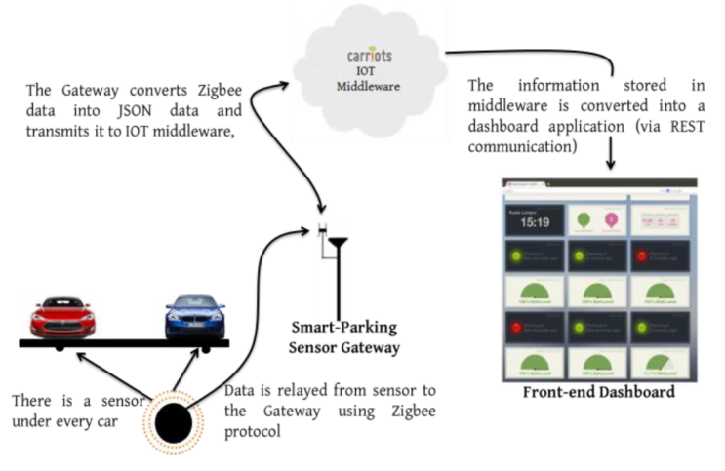
- Diagram of Smart Parking Deployment Setup
Figure 4 shows an excerpt view smart-parking system deployment. Following the architecture described in section II, the deployment includes wireless sensor network, IOT platform and front-end dashboard.

Setup of Smart-Parking Sensor
For our experimental setup, we deploy seven (7) wireless sensor nodes on the asphalt at each outdoor parking spot. These sensors are packaged to comply IP68 [16], thus, it is suitable for outdoor parking. The sensors are equipped with ferromagnetic sensor. It is used to detect slight changes in the terrestrial magnetic flow originated by the close presence of a metallic voluminous object (e.g. car). The sensor communicates with each other as well as with the gateway via a 2.4-GHZ radio transceiver using Zigbee based IEEE 802.15.4 [17]. Combination of Zigbee and IEEE 802.15.4 technology enable multi-hop communication for the sensors to reach their gateway. The detail of sensor hardware specification is shown in table I.
Table 1 Sensor Hardware Specification
Attributes | Features
Wireless Radio Frequency | 2.4 Ghz
Communication Range | Up to 100m
Detection Technology | Ferromagnetic Sensor
Predicted Battery Life | +/- 2 Years
Load Resistance | 20 tons
Protection | IP68
Work Condition | All weather
Installation | Surface mount

Setup of Smart-Parking Gateway
As for the gateway deployment, in this experimental setup, we use one gateway to connect seven parking sensors to the cloud. In larger deployment more gateways may be required for effective and efficient data propagation. Unlike sensor nodes, the gateway has a reserved power supply and equipped with internet connection to transmit sensor data to the IOT middleware.
The smart-parking gateway is developed on an outdoor unit of a Linux-based machine. It features with Zigbee Interface and Wifi card for internet connection to the IOT middleware. The gateway adopts a standard REST API that specifies the provided services by IOT Middleware (Carriots platform). Table 2 shows detail hardware specification used for our smart-parking gateway.
Table 2 Specification of Smart Parking Gateway
Attributes | Features
Hardware Model | Alix 6F2.
Processor | 500 Mhz AMD Geode
Operating System | Voyage Linux
Internet Connection | WLAN 802.11a/b/g
Sensor Network Interface | Zigbee over 802.15.4
Power | DC Jack

Setup of IOT Middleware and Front-end Dashboard
The purpose of this paper is to demonstrate and discuss development of smart-parking system by leveraging available Platform as a Service (PaaS) for both IOT middleware and Dashboard Front-End. Therefore, the setup for the IOT middleware and Dashboard Front-End is done online through the platform website.
For the IOT middleware we use Carriots platform [12] as a data platform for our Smart-Parking System. The general workflow on using the platform are connecting all sensors, collecting the data, managing all data and build business rules to consume the data.
Trough Ducksboard platform [18], we can setup data reporting dashboard via provided visualization widget. Therefore, the data collected and managed by Carriots platform is further passed to Ducksboard platform using REST communication for easy and informative visualization.

Implementation Details
In this section, we discuss more details on the implementation of smart-parking system. We will highlight the sensor data creation during the sensor network deployment. The integration with IOT middleware and front-end dashboard application is also discussed.

Sensor Data Creation
In our parking sensors, when parking sensors detect the presence/absence of the vehicle over the parking slot, the sensor creates the data payload of 8 bytes over Zigbee packet format. The fields of the data payload are sensor_id, battery_level, slot_availability status and reserved bytes. Each field occupies two bytes as shown in figure 5.

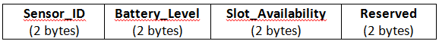
- Payload of Parking Sensor
This data packet is generated by the parking sensors and transmitted to the gateway as the bridge to reach the IOT middleware.

Integration with IOT Middleware
In Carriots middleware, every physical sensor devices is registered, deployed and monitor on the cloud. The sensor data feeds from parking sensors are associated with these devices. For the data interchange, REST API is the way devices and other systems interact with this platform. The data is represented in JavaScript Object Notation (JSON) format, a standardized human readable data interchange format.
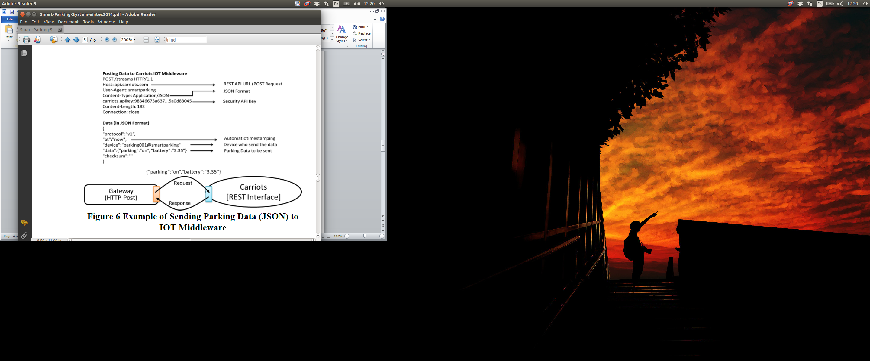
- Example of Sending Parking Data (using JSON format) to IOT Middleware
Upon receiving raw data from parking sensor, the Sensor Gateway (via its gateway’s translator module) extracts Zigbee message format (see figure 5) and translates it into JSON format (see figure 6). Finally the REST module sends the data encapsulated in JSON object to Carriots Middleware. The REST module on the gateway is implemented using Lib-curl library [15]. Figure 6 below illustrate JSON data format and REST communication between the gateway and the Carriot IOT middleware.
The next step after collecting data of sensor parking data is building rules and business logic related to smart parking system. This can be achieved by hosting a Groovy Script as Processing Module on Carriots server. In our system, it has two simple business logic and rules:

- Measuring parking occupancy (number of occupied or available parking) and forward the measurement data to the front-end dashboard.
- Upon receiving every sensor data, forward the sensor’s occupancy status and sensor’s battery status to the front-end dashboard.

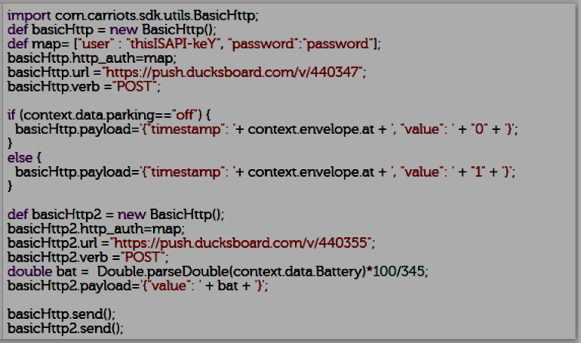
- Snippet of Groovy Script on Carriots Middleware
In figure 7 above, we provide snippet of the groovy script that listen to the incoming data and forward them to the front-end dashboard. The snippet is extracting the parking occupancy and battery level status from received JSON data, and then forwards the information to front-end dashboard (Ducksboard). The front-end dashboard shown in figure 8 is also built upon REST API, hence the communication between IOT middleware and front-end dashboard can be easily perform using REST communication.
Figure 8 shows the front-end dashboard of the smart-parking system. The graphical user interface (GUI) and communication is built quickly and rapidly using GUI widget and REST API communication provided by Ducksboard Platform. As it can be seen from the figure, the dashboard keeps track the occupancy of each parking slot/bay as well as battery level of each sensor. The dashboard is the final user interface that customer really see and use. It can be viewed using web browser as well as smart phone.
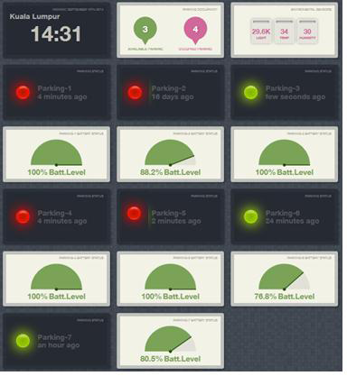
- The front-end dashboard of smart-parking system

Conclusion
In this paper we describe the adoption of Platform as a Service to develop smart-parking system. The system is built rapidly using available platforms on the cloud (PaaS). The Carriots platform is used as IOT middleware and The Ducksboard Platform is used for front-end dashboard. Through the whole developing phase of smart-parking system using PaaS, we can confidently conclude that utilizing a PaaS development environment has resulted in the creation of smart-parking system being significantly faster than would otherwise be the case. The other main benefits we can conclude from using PaaS (e.g. Carriots,Ducksboard etc) as cloud-based platform for developing IOT solution are:
- Time – reduce development time.
- Cost – reduce development cost and maintenance.
- Flexible – one platform can flexible collaborate with another platform using RESTful communication and common JSON data format.

References
- D. Giusto, G.Morabito, A.Iera, and L.Atzori, “The Internet of Things”.Springer, ISBN: 978-1-4419-1673-0 preface, pp.4, 2010.
- Wikipedia website. [Online] – Internet of Things - http://en.wikipedia.org/wiki/Internet_of_Things.
- The Hitachi website [Online] – Concept of Smart Cities. http://hitachi.com/products/smartcity/vision/concept/index.html
- The IBM website [Online] – Smart Cities. http://www.ibm.com/smarterplanet/us/en/smarter_cities
- P.Vijay Kumar and Siddarth T.S, “A Prototype Parking System using Wireless Sensor Networks”, International Journal of Computer Communication and Information System (IJCCIS), vol.2, no.1 ISSN:0976-1349, July-Dec 2010.
- L. O. Urdiain, C. P. Romero, J. Doggen, T. Dams and P. Van Houtven, “Wireless Sensor Network Protocol for Smart Parking Application Experimental Study on the Arduino Platform”, in 2nd Int. Conf. Ambient Computing, Application., Services and Technologies.- AMBIENT’12, Sep. 23-28, 2012, pp. 45-48.
- M. S. Karunarathne and L. D. J. F. Nanayakkara, “A Prototype to Identify Availability of a Car in a Smart Car Park with Aid of Programmable Chip and Infrared Sensors”, Journal of Emerging Trends in Computing and Information Sciences (CIS Journal), Vol. 5, No. 2 February 2014.
- S. V. Srikanth, Pramod P. J., Dileep K. P., Tapas S., Mahesh U. Patil, Sarat Chandra Babu N, “Design & Implementation of a Prototype Smart Parking(SPARK) System using Wireless Sensor Networks,” International Conference on Advanced Information Networking & Applications workshops, 2009.
- M.Y.I. Ideris, Y. Y. Leng, E. M. Tamil, N.M. Noor and Z. Razak, “Car Park System: A review of Smart Parking System and its Technology”. Faculty of Computer Science and Information Technology, University of Malaya, Malaysia.
- Andrea Zanella, “Internet of Things for Smart Cities” IEEE Internet of Things Journal, Vol.1, No.1, February 2014.
- Soua, R., Minet, P, “A survey on energy efficient techniques in wireless sensor networks”. Wireless and Mobile Networking Conference (WMNC), 2011 4th Joint IFIP , vol., no., pp.1,9, 26-28 Oct. 2011.
- Carriots Platform as a Service [Online] – https://carriots.com
- Xively IOT Platform [Online]– https://xively.com
- Jiehan Zhou, Leppanen, T, Harjula, E. Ylianttila, M. Ojala, T. Chen Yu, Hai Jin, Yang, L.T, “CloudThings: A common architecture for integrating the Internet of Things with Cloud Computing.” Computer Supported Cooperative Work in Design (CSCWD), 2013, vol., no., pp.651,657, 27-29 June 2013.
- libCurl Library for REST Client [Online]– http://curl.haxx.se/libcurl/
- International Protection Marking (IP Code) [Online] - http://en.wikipedia.org/wiki/IP_Code
- IEEE Standard for Local and Metropolitan Area Networks—Part 15.4: Low-Rate Wireless Personal Area Networks (LR-WPANs), IEEE Standard 802.15.4-2011.
- Ducksboard Realtime Web Dashboard [Online]- https://ducksboard.com/

